
Francesco MARCHI
Director General
____________________________

Phone: +32.2.285.48.92
francesco.marchi@euratex.eu



Association n° 06/2016

11th March 2016

EURATEX joint BOARD & Directors General MEETING
Points 7 of the agenda of 11th March 2016

 Summary:
Ahead of the minutes of the joint Board of Directors and Directors General meeting of today, please find appended the presentation from Roberta Adinolfi on the recent trends and prospects in the T&C industry (point 7 of the agenda).

(Original signed by)
Francesco MARCHI
Director General

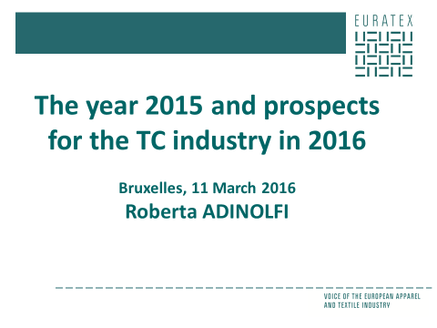

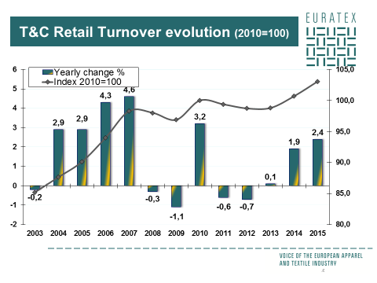

T&C retail sales evolution
Retail sales growth remains on an upward trajectory, adding to signs of a strengthening EU economy. The retail sales evolution in the T&C industry was up 2.4% in 2015, fueled by a stabilisation of consumer prices.
The retail activity expanded strongly in most EU countries with the exception of:
France, Germany and Austria, where the activity remained almost stable and of Finland, Bulgaria and the Netherlands where sales decreased in 2015.

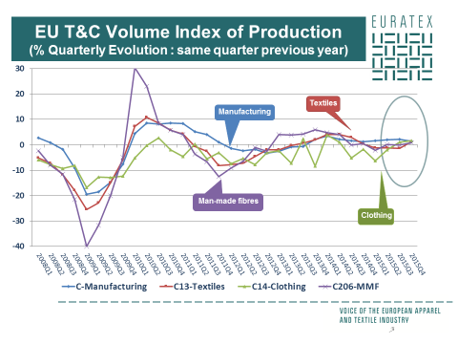

T&C production evolution
Contrary to the retail sales, the European T&C production was lower than in the previous year, despite better performances during the second part of 2015.
- Textiles’ output declined by -0.7%.
- Production in the MMF industry went down by -0.4%.
- The -1.5% slowdown in clothing production, despite a surge in turnover and exports, suggests a weakening of domestic demand for European clothing products.

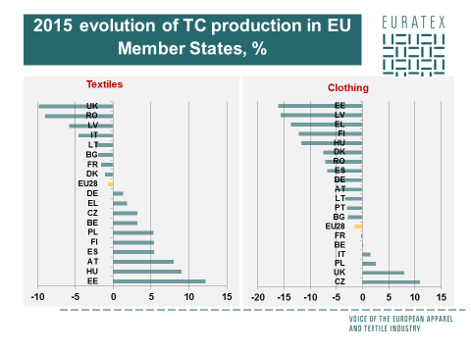

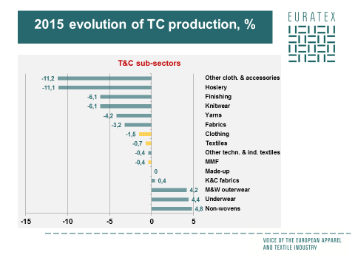

1/ The breakdown by MS shows that:

Textiles: There are big divergences among Member States with a slump above 4% in UK, Romania, Latvia, Italy and high output growth in Poland, Spain, Finland, Austria, Hungary, and Estonia.

Clothing: The majority of Member States experienced output drop, with the exception of Italy, Poland, UK, and the Czech Rep. Finally, production in France and Belgium was stable.
Not data for: IE, HR, NL, SI, SK, SE, LU, PT (textiles)

2/ Among sub-sectors,…
The non-woven, underwear and men’s and women’s outerwear, performed relatively well with growth rates above +4%,
while fabrics, yarns, knitwear, finishing, hosiery and other clothing & accessories, were greatly affected.

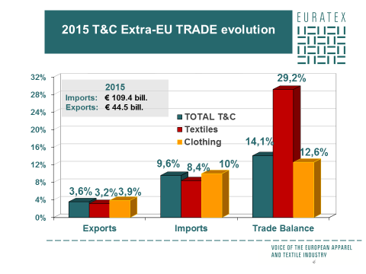

EU trade evolution
EU T&C exporters increased moderately their market shares in Third countries during 2015 (+3.6%).
Extra-EU imports evolution was 3 times higher than for exports: with an increase of +8.4% (T) and +10% (C).
As a result, imports reached € 109 bill. in 2015 and exports 44 bill.
This evolution impacted the overall trade balance of the EU which deficit deteriorated again in value by +14%.

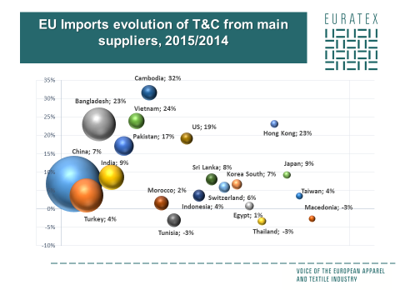

IMPORT evolution with EU key suppliers
NB: the % represent the 2015 evolution, and the size of the bubbles are determined by the import values.

EU imports went up due to sharp increases from some Asian countries. On the contrary, imports from the Mediterranean area realized a modest growth or even decreased over the period.
Looking at T&C separately:

Textile imports coming from EU top-15 suppliers were all up, except from Egypt & Thailand. The US witnessed the highest growth (+19%), followed by Pakistan, China & Vietnam (+11%).

Clothing imports coming from EU top-15 suppliers were all up except from Tunisia & Thailand. Bangladesh, Cambodia, Vietnam, Pakistan, Hong Kong and the US recorded growth rates above 24%.

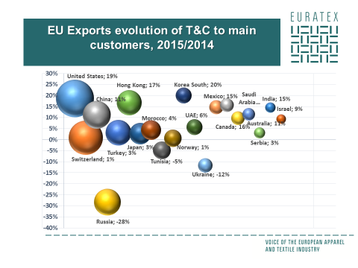

EXPORT evolution with EU key customers:

Exports went up due to sharp increases on the US, EU’s top market, supported by a favorable exchange rate. This positive evolution was partially offset by the slump in Russia and Ukraine, as economy remains depressed.

Textiles’ sales to the U.S., recorded a +16% increase. As well as exports to South Korea, Mexico and India (+16% on average). On the contrary, exports to Russia and Ukraine slipped back again by respectively -27% and -1%.

Clothing exports data shows a sustained growth in the U.S., Hong Kong, South Korea, Canada and China (with rates between +19% and +22%), which made the US the 2nd largest EU customer. Exports to the Saudi Arabian and Mexican markets also revealed a significant expansion (with respectively +17% and +15%). Russia and Ukraine on the other hand declined by -28%.

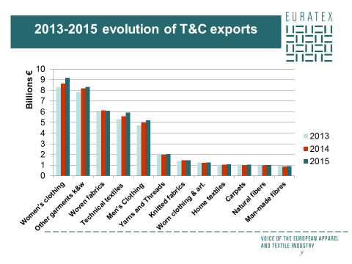

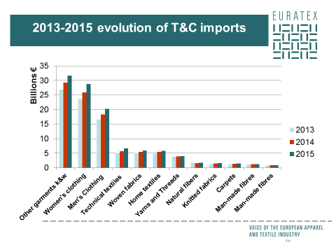

The export breakdown in the textile sector suggests that the best exporters’ performances in Third markets were achieved in the market of technical textiles, which increased by +6% in 2015 (6 bill. €).
In clothing, exports performed well, with women’s clothing products showing the biggest increase in export value, reaching 9.2 bill. € in 2015 (+6%).

The breakdown of imports by category indicates an increase in all products of the value chain. Technical textiles, as well as women’s and men’s clothing were the products registering the largest increases, with respectively +17% and +11%, followed by other clothing articles (+8%).

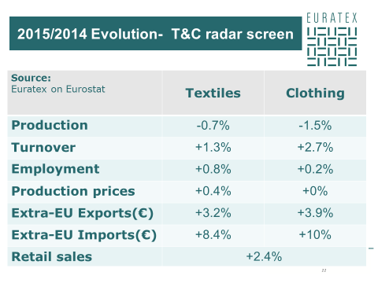

To summarize : The T&C activity in the EU gained some momentum in particular towards the end of 2015.
- However, T&C production is lagging behind despite economic recovery and declined by -0.7% (Text) and -1.5% (Clo), as output growth achieved during the last quarter did not managed to offset the severe drop recorded in the 1st Q of 2015.
- Companies’ turnover evolution went up in both T&C by respectively +1.3% and +2.7%, outpacing the total manufacturing growth.

The situation of EU employment continues to improve with job creation in both sectors. Pricing conditions were acceptable with moderate growth in domestic producer prices. Finally, another positive signal comes from the retail sales that went up by 2.4% and from Extra-EU exports, which provided a limited but still positive impetus to activity.

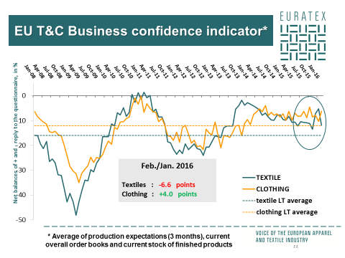

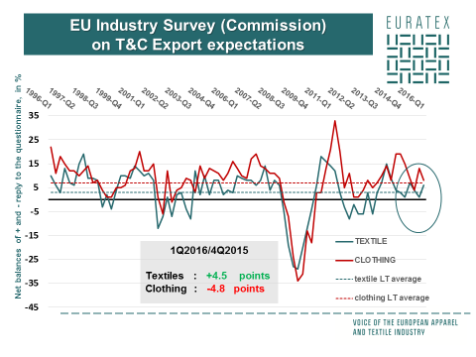

Business short-term prospects

According to the qualitative indicators from the latest Commission Business survey (February), which gives some indication on the short term prospects in the T&C industry:

The textile industrial confidence revealed a negative development. This was the result of:
- managers’ more negative assessment of the stocks of finished products, of production expectations and of order books levels.
- Besides, employment expectations for the months ahead also deteriorated.
On the opposite, the industrial confidence in the Clothing industry improved in February, with
- An upward revision of managers’ production expectations, more positive views on their stocks of finished products
- and on their order books levels.
In addition, employment expectations also improved

Regarding short-term TRADE prospects during the 1Q2016, business assessment improved in the textile industry with more positive views on their export expectations for the months ahead. Also their expectations on their competitive position outside EU improved.
By contrast, export expectations in the clothing sector deteriorated, as the expectations on the competitive position outside EU.

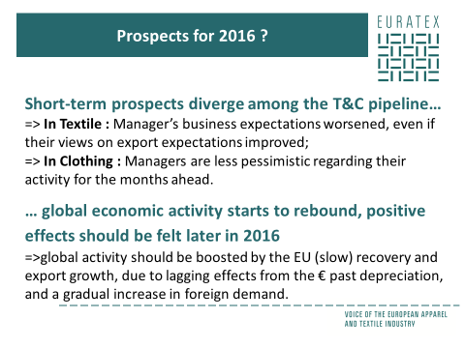
What can we expect for 2016?
Short-term prospects diverge among the pipeline
According to the Commission survey, evolution in business confidence for the months ahead shows that,
- Manager’s short-term expectations worsened in the EU textile industry (in particular in Germany, Lithuania, Hungary, Austria and Finland).
- While managers are less pessimistic in the clothing industry (in particular in Belgium, Estonia, Spain, France, Finland and Sweden).
- By contrast, export expectations as well as manager’s expectations on their competitive position outside the EU are more positive in the textile industry than in the clothing sector.
Positive effects should be felt later in 2016
- Looking to 2016 as a whole, Member States should continue moving along a recovery path.
- Euro area export growth should accelerate over the course of 2016 due to lagging effects from the euro’s past depreciation, and a gradual increase in foreign demand.
- This evolution is expected to boost global activity and also bring some positive developments for the T&C industry by end of the year.

